How to Name Your Photo Folders
Oct 22, 2026 · @Mikkel Christensen

The basics
Sorting your photos takes three steps:
- Drag your photos into the Put New Photos Here folder on your photo drive.
- Double-click Organize Photos.
- Wait for the message that says it's done. Your photos are now in My Photos.
You don't have to name anything. Photos from your phone or a newer camera already know their date, so you can drop them in loose.
Naming folders is only for two jobs:
- Grouping photos from a trip or event.
- Telling the app the date of old photos that don't know their own.

Trips and events
To group photos from a trip, put them in a folder named TRIP - followed by the trip's name and year. The photos still go into By Date like always, and they also show up together in By Trip.
Type the folder name exactly like this:
- The word TRIP or EVENT in capital letters.
- A space, a dash, and another space.
- The name, ending with the year.
Name the folder | Find the photos in
TRIP - Hawaii 2026 | By Trip ▸ Hawaii 2026
TRIP - Yellowstone 2019 | By Trip ▸ Yellowstone 2019
EVENT - Christmas 2026 | By Event ▸ Christmas 2026
EVENT - Family Reunion 2024 | By Event ▸ Family Reunion 2024
- Always end with the year. If some photos in the folder don't know their own date, the app uses that year for them.
- Spell it the same way every time. To add more Hawaii photos later, name the new folder TRIP - Hawaii 2026 again, and they join the same trip.
- A folder with no dash at all, like Grandma's Recipes, becomes an album in Albums.

Setting the date yourself
If you know when photos were taken, name the folder DATE - followed by the date. Use this for scanned prints, old photos, and any camera whose clock was set wrong.
Write only as much as you're sure of:
If you know... | Name the folder
The year | DATE - 2009
The month and year | DATE - June 2009
The exact day | DATE - July 4 2009
Only the decade | DATE - 1990s
- Write the month as a word (June, not 6), so it can't get mixed up.
- For a season, use just the year. Write DATE - 1998, not DATE - Summer 1998.
- Not sure of the month? Leave it out. A photo filed under the wrong month is hard to find later.
- A DATE folder replaces the camera's date for every photo inside it. Only put photos from that one time in the folder.
- If the app can't read the date, it puts those photos in Unsorted and tells you.

Using a trip and a date together
To give old trip photos both a trip name and a date, put one folder inside the other.
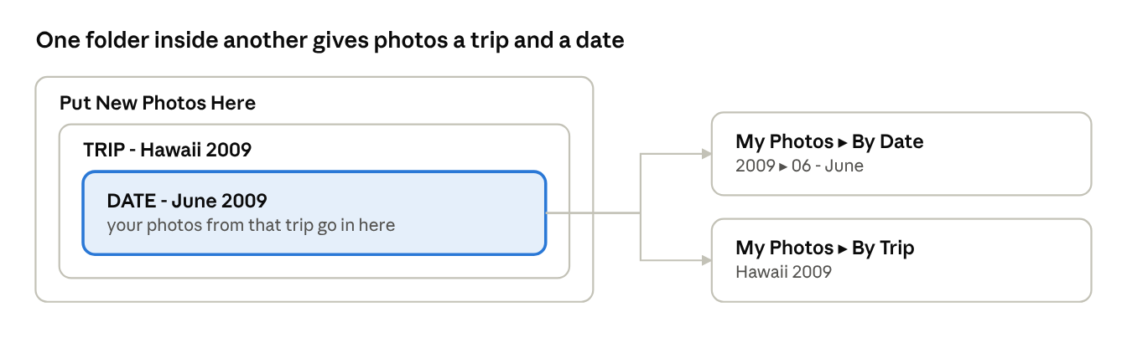
a DATE folder inside a TRIP folder · where the photos land
Make the TRIP folder first, put a DATE folder inside it, then put the photos in the DATE folder. They land in By Date under June 2009 and also show up together in By Trip. Phone photos already know their date, so they only need the TRIP folder.

Old photos and scans
Old photos are where folder names matter most, because many of them don't know their own date.
- Scanned prints always need a DATE folder. A scanner stamps the day you scanned, not the day the photo was taken, so the app ignores that date. Scans without a DATE folder go to Unsorted.
- Sort them into piles first. Make one DATE folder for each time you know, then drop them all in together.
- Only know roughly when? Use the decade, like DATE - 1980s.
- Already have folders named by year on your computer, like 2004 or Christmas 2009? Drop them in as they are. The app uses those years for photos that don't know their date.
- No idea when? Drop them in anyway. They go to Unsorted, where you can sort them later.
- Dropped the same photos in twice? That's fine. Extra copies go to Duplicates (safe to delete).

Fixing things later
You can move photos around in My Photos yourself, and the app will remember what you did.
- Unsorted holds photos without a date. Folders named Probably 2008 (and so on) are the app's best guess. If a guess looks right, drag the folders inside it into that year in By Date.
- Know when a photo was taken? Drag it into the right year and month folder in By Date. If you only know the year, drag it into the year folder.
- Photo in the wrong month? Drag it to the right one. Your choice wins, even over the camera's date.
- You can make your own folders inside a month, like 07 - July ▸ Beach Day.
- Renaming a trip in By Trip is fine. The new name sticks.
- To delete a photo, delete it from By Date. The photos in By Trip and By Event are shortcuts, so one deleted there comes back the next time you sort.
- Duplicates (safe to delete) can be emptied whenever you like.

Cheat sheet
I want to... | Name the folder
Sort phone photos | No folder needed. Drop them in loose.
Group a trip | TRIP - Hawaii 2026
Group an event | EVENT - Christmas 2026
Make an album | Grandma's Recipes (no dash)
Set the year | DATE - 2009
Set the month | DATE - June 2009
Set the exact day | DATE - July 4 2009
Set the decade | DATE - 1990s
Group a trip and set its date | TRIP - Hawaii 2009, with a DATE - June 2009 folder inside it

Rules to remember
- Only drop new photos into Put New Photos Here. Don't rename or move Put New Photos Here, My Photos, or Organize Photos.
- Wait for the done message before you unplug the drive.
- Eject before unplugging. In Finder, click the eject button next to the drive's name, then unplug it.
- Nothing can be lost. The app never deletes a photo. If something goes wrong, your photos stay where they were.
If you see a message that something went wrong, or anything looks strange, call or text Mikkel. The app keeps a record of what happened that he can check.

